**Part 2: DIY -> CHIC - The making of new instruments**

**Ceramics**

Just like many others in the long and solitary COVID lockdowns of the early 2020s, Niki took up some new creative hobbies to pass the time. For her, these included making wonky and voluptuous clay ‘vases’ with ladder-like grooves running up and down the sides. These clay pieces were taken to a local kiln available for public drop off and firing, and were turned from greenware (wet and a bit leathery) to bisque (hard, brittle and ready to last a long time unless dropped).

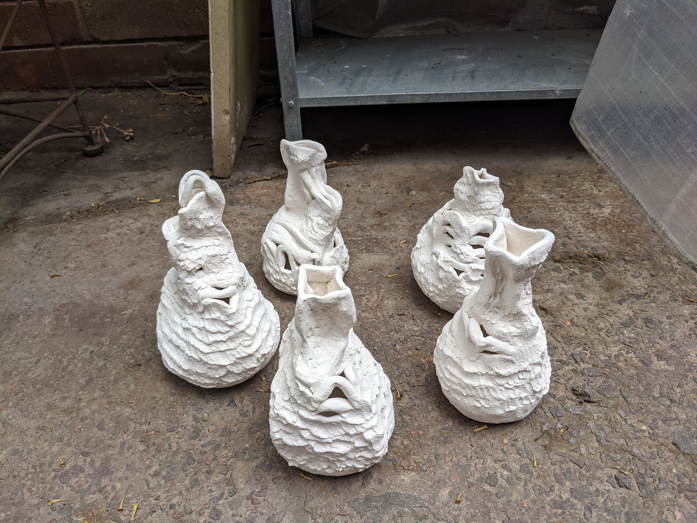

Figure 1. Ceramics fresh out of the kiln at Sydney Clay, 2020.

Their textual surfaces and cavernous spaces made them tantalising invitations to touch and draw sound from. As a percussionist, it did not feel like a big leap for Niki to take a few sticks and mallets to them after they had come out of the kiln, crispy and lumpy. It was in a process of experimenting with rattan mallet handles, and glass and plastic glockenspiel and xylophone mallets, that Niki discovered the unique microtonal pitches within each object and across the set, as well as delicate and brittle timbres. Scraping and tapping led to tinkling, and surprisingly resonant sounds.

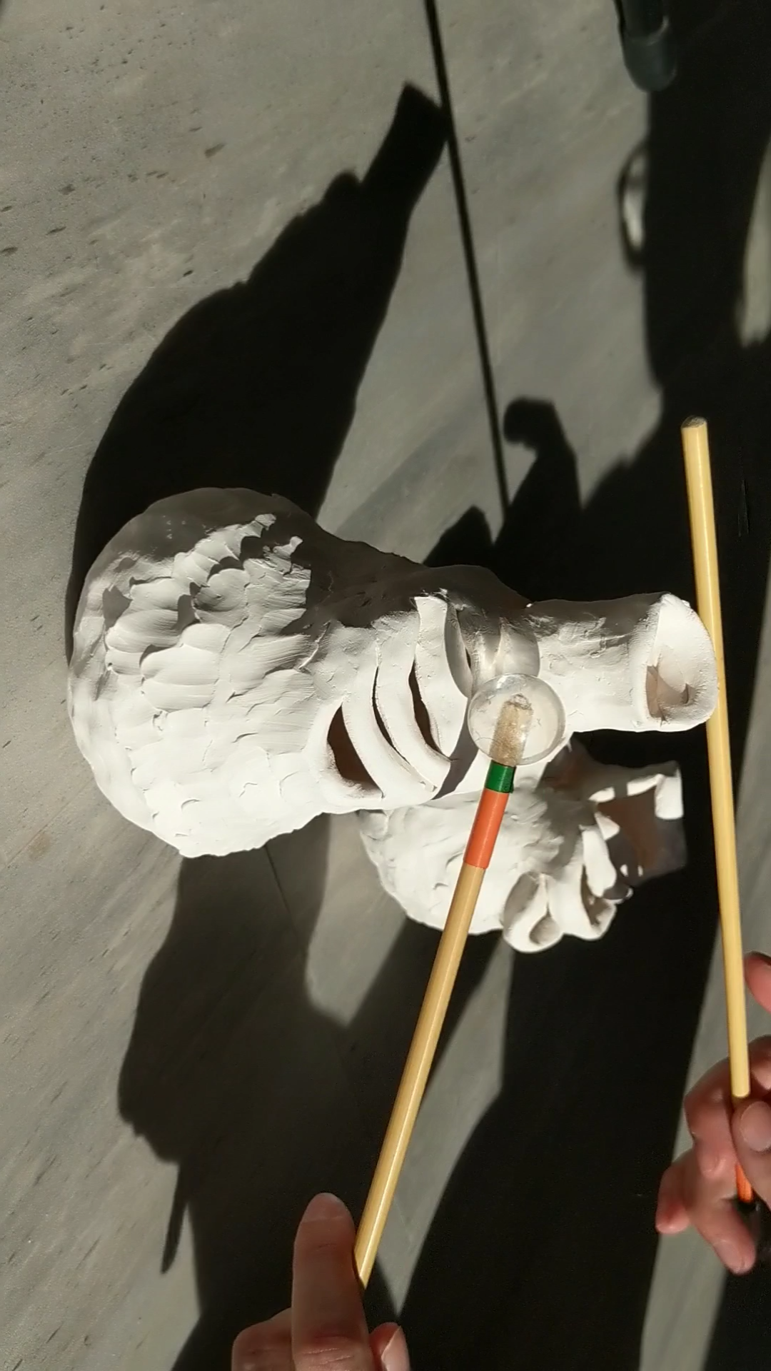

Figure 2. Niki scraping ceramic instrument with glass glockenspiel mallet, 2020.

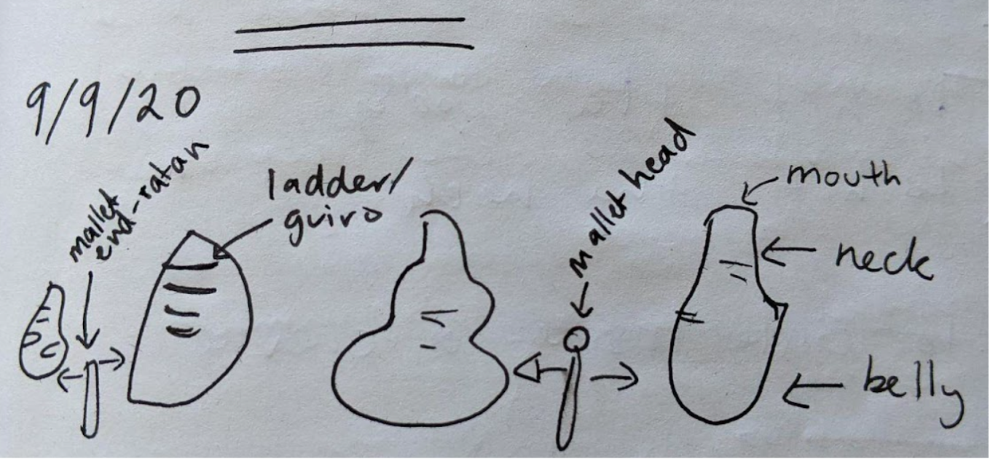Figure 3. Sketch noting playing techniques on a series of ceramic vessels, 2020.

**Bamboo**

Thinking that perhaps there was something interesting here, Niki approached colleague and percussionist friend Hamish Upton, asking if he thought there was some musical merit in these new objects. From here, the two percussionists set about scheming a musical and performative work with new instruments made only from natural materials.

Hamish was particularly interested in the ‘ladder’ element of the ceramics which created a guiro-like effect when scraped. Guiros, for context, are instruments with a serrated surface originally made from a gourd that creates a rasping sound when scraped, and are traditionally used in Latin American music.[1] Combining the guiro with the ceramic ladder idea, Hamish set about sourcing different lengths of bamboo and carving grooves into them. As Hamish experimented with the sounds of his bamboo guiros, he found he had successfully created a rasp-able instrument, with a new and distinctly bamboo resonant timbre. This timbre had a long decay and a series of low fundamental pitches, combined with higher partials in the moment of scrape.

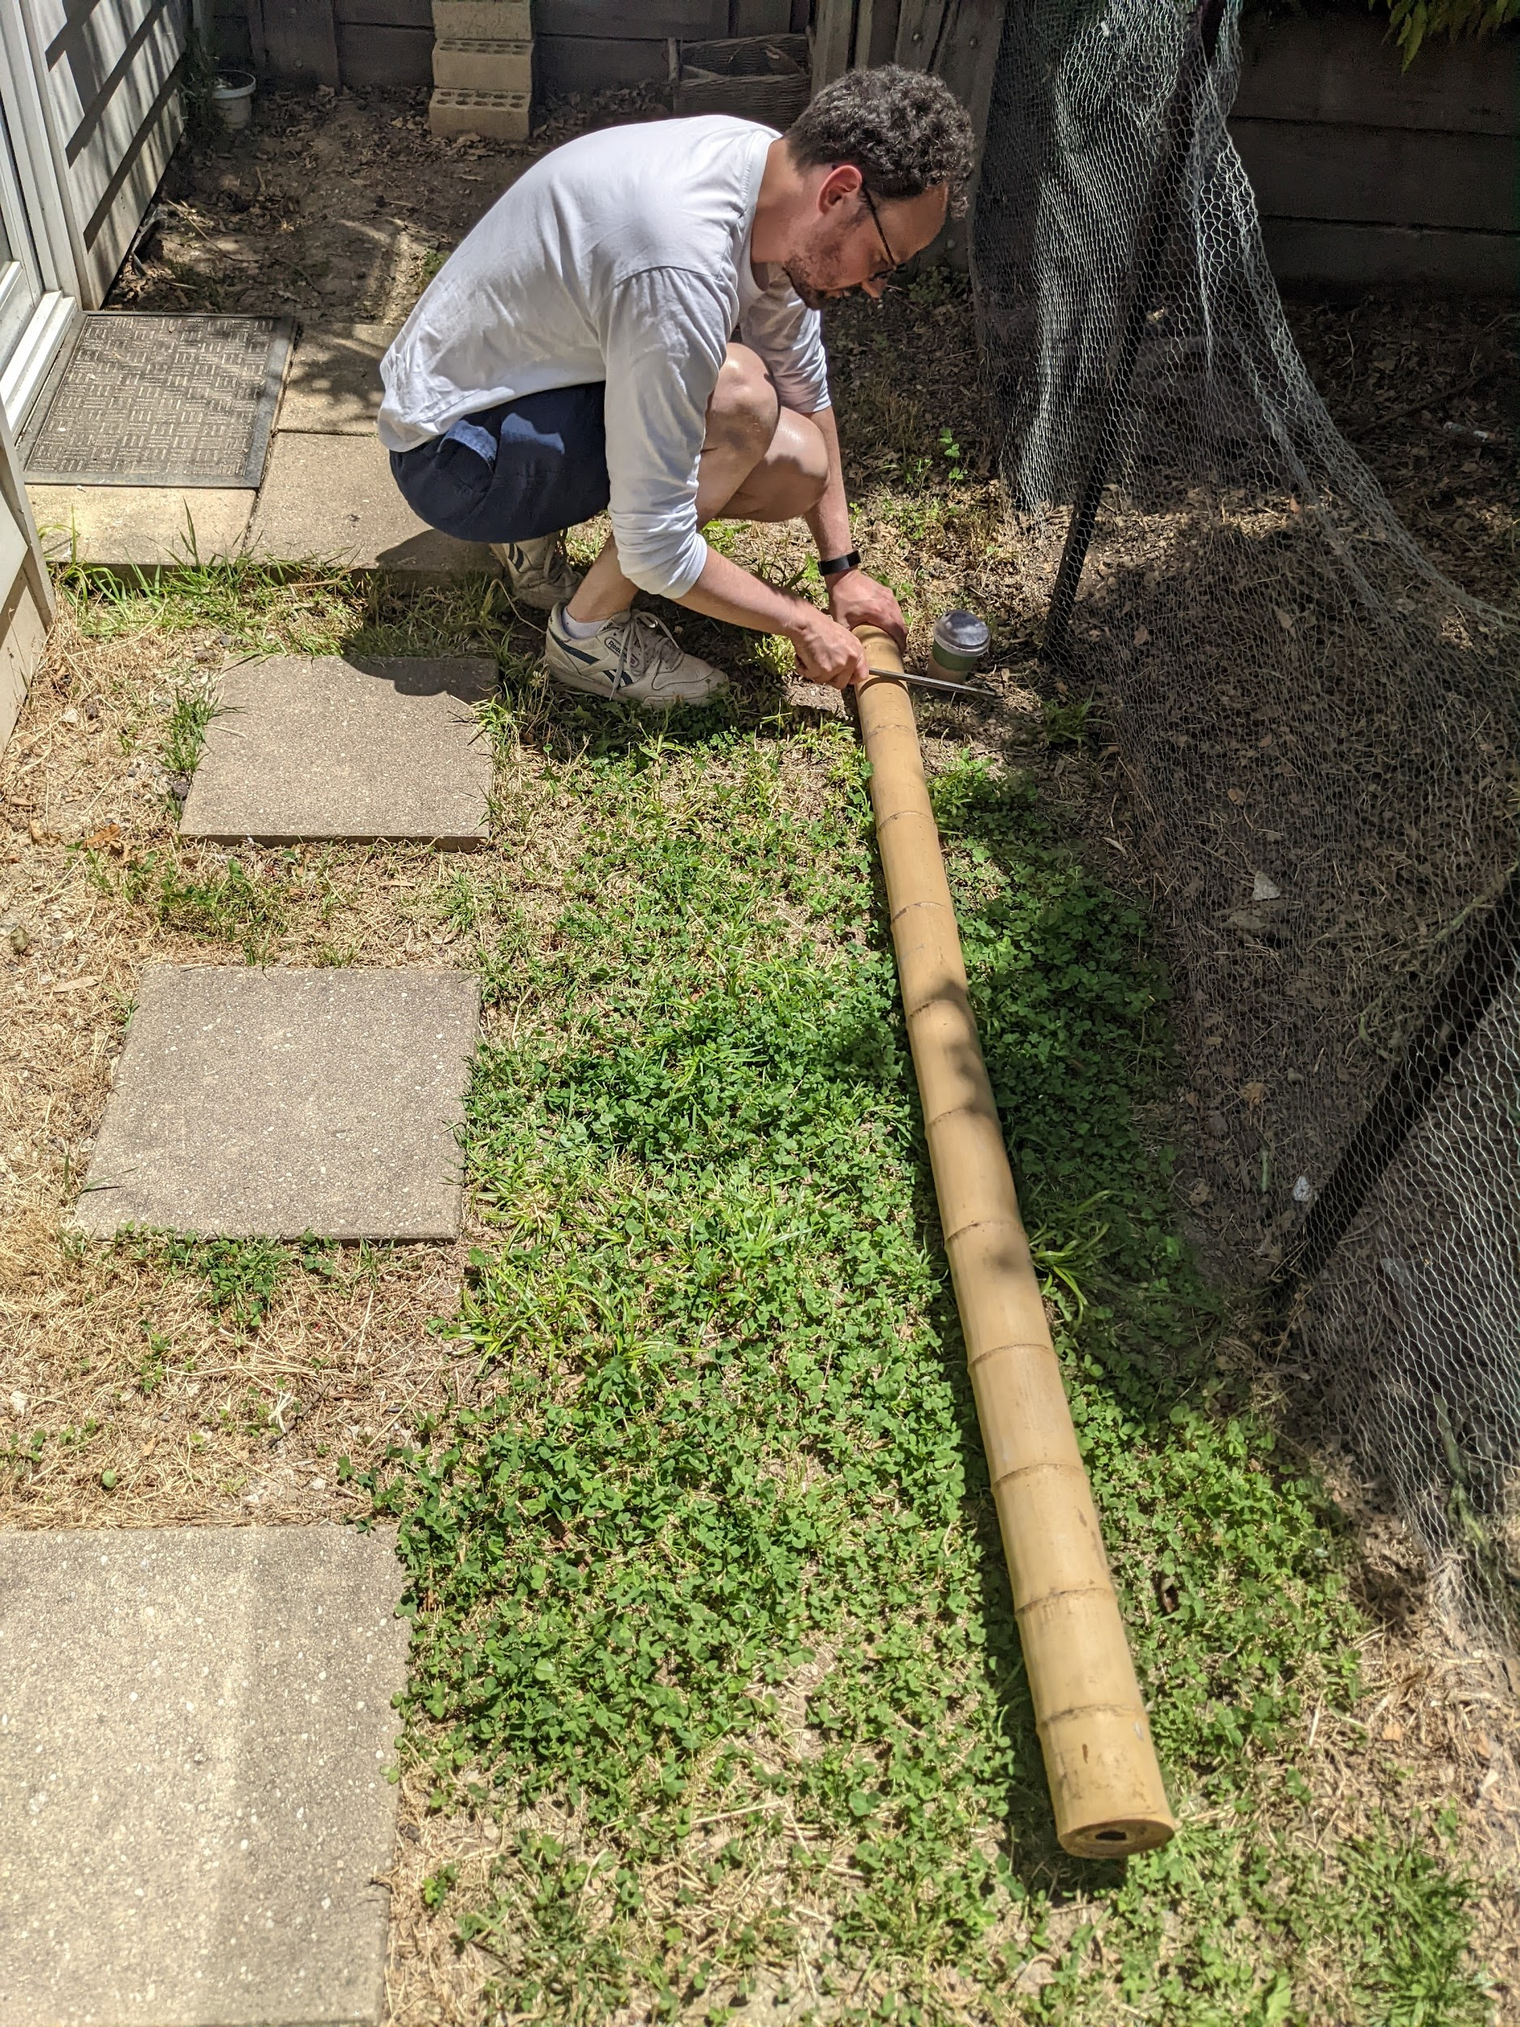

Figure 4. Hamish carving grooves into bamboo length, 2020.

With the slowly growing collection of bamboo and ceramic instruments, the two percussionists set about creating a work for the Speak Percussion Bespoke Artist program of which the artists were a part of.[2] *Navigating Distance & Closeness* took these instruments and created a musical composition and public performance featuring exclusively the sounds of the new instruments. In a process of developing the musical composition, the artists considered the key themes shaping their collaboration.

**Distance & Closeness**

The major factor affecting this early stage of the work development, was that each artist was based in a different city, (Niki in Sydney and Hamish in Melbourne) so the artists communicated via zoom, calls and emails in a process of creating their part of the work across a great distance. They set out to find the commonalities and contrasts in the texture, sound, and playability of their respective instruments, sending each other sound clips and videos of prototype sounds and compositional ideas.

It was this process of collaborating that led the artists to explore closeness and distance as key themes of the work. In considering the ways this theme could be both in the musical composition and the physical performance, the artists explored a potential presentation model involving multiple percussion setups, some far away from each other, and some right next to each other. Here, during performance, the artists would at times be on opposite sides of the room trying to hear and be heard across a vast distance, and at other times, side by side sharing the same instrument. With this compositional idea in mind, the artist set about designing the installation element of presenting the work.

**Installation**

Experimenting with how to present the bamboo and ceramics, the artists explored suspending the bamboo for maximum resonance, and placing the ceramics on a sturdy table to minimise their chance of falling and breaking.

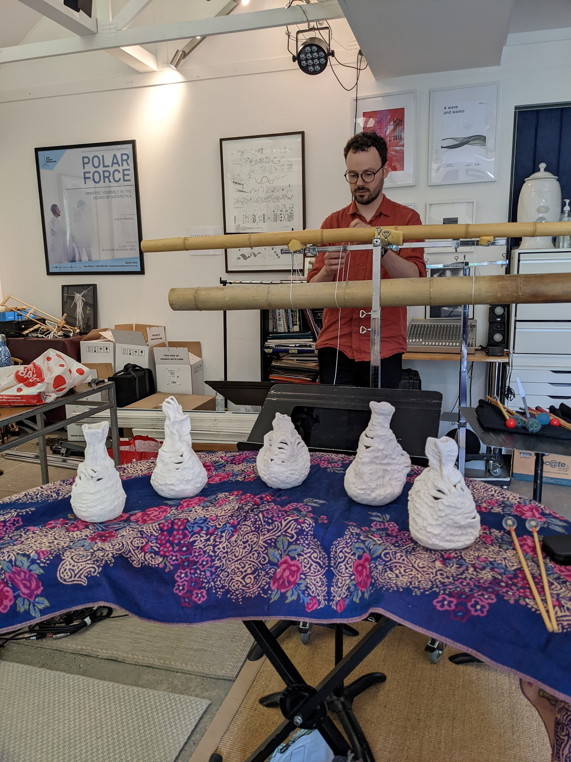

Figure 5. DIY Set up at Speak Percussion studio, 2021.

As the artists wanted the work to highlight the new sculptural instruments, they decided to steer away from using conventional percussion infrastructure - in this way, drawing attention to the visual design of the new instruments in an almost sculptural context. As such, they designed a table for the ceramics (affectionately termed the ‘macaroni’ table as its shape enveloped the player standing inside) and a tripod setup that suspended the bamboo. Both setups supported the instruments in a unique playing position, inviting new ways to perform on the instruments in space across stacked horizontal planes and semi-circular layouts.

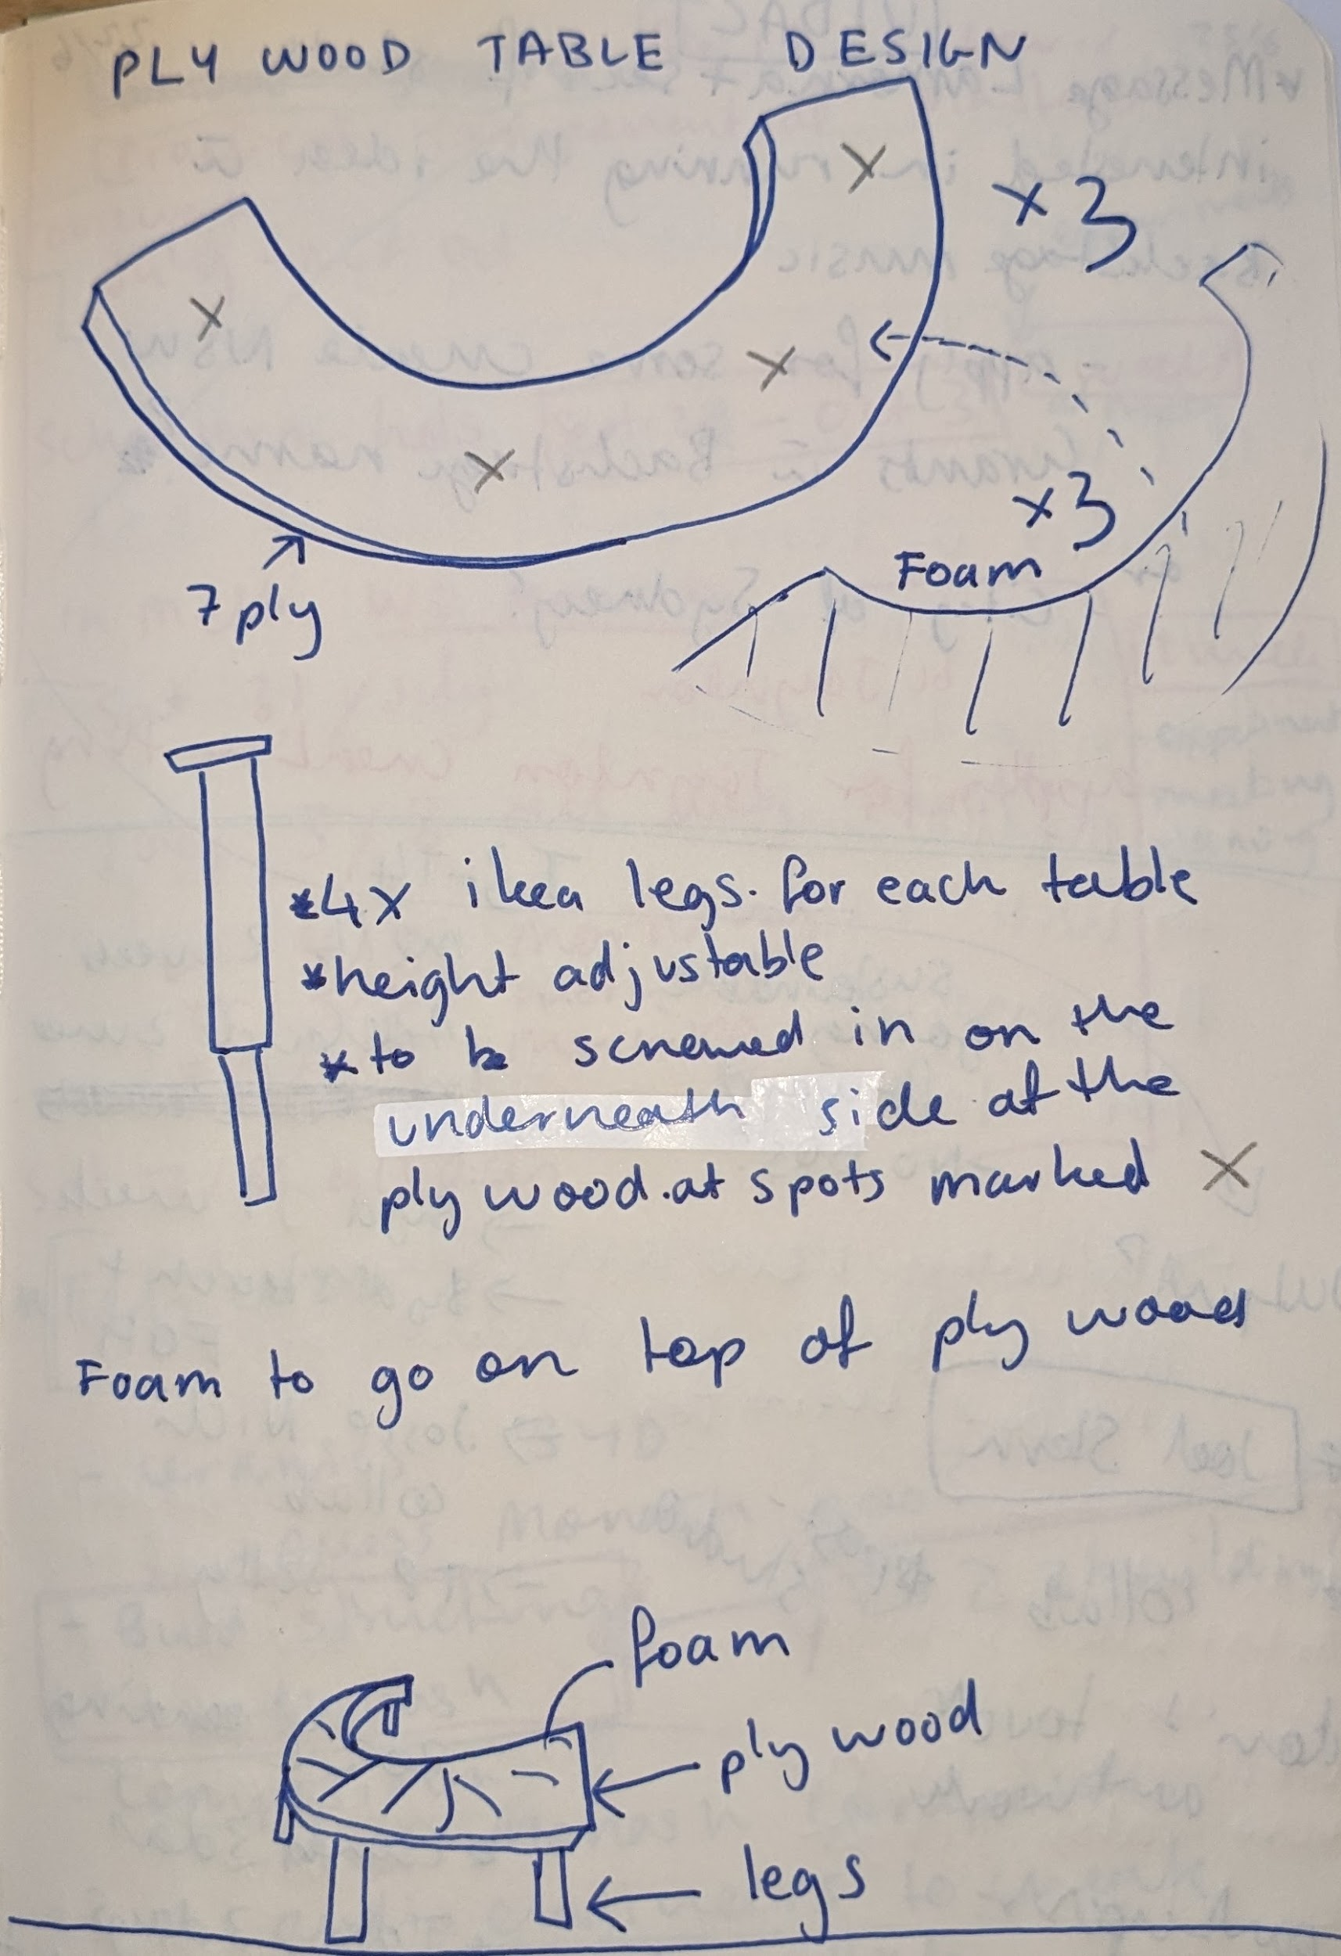

Figure 6. Table design

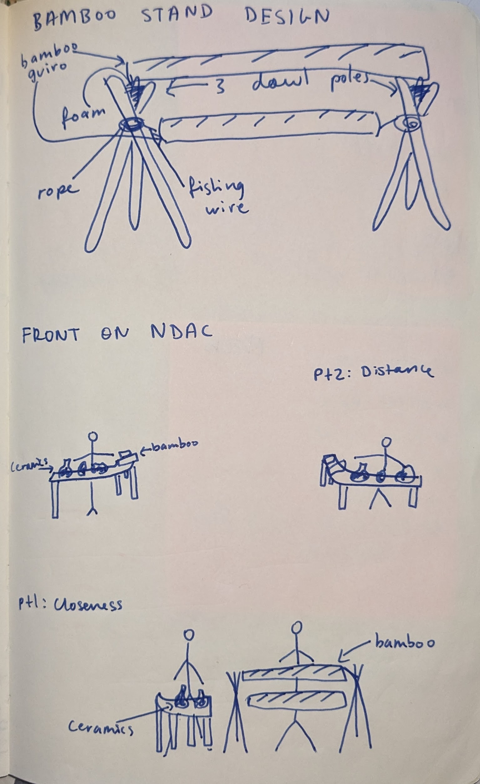

Figure 7. Bamboo suspended design

Hamish set out to make this new infrastructure using his friends’ skills in woodwork, with a black spray painted finish on each object.

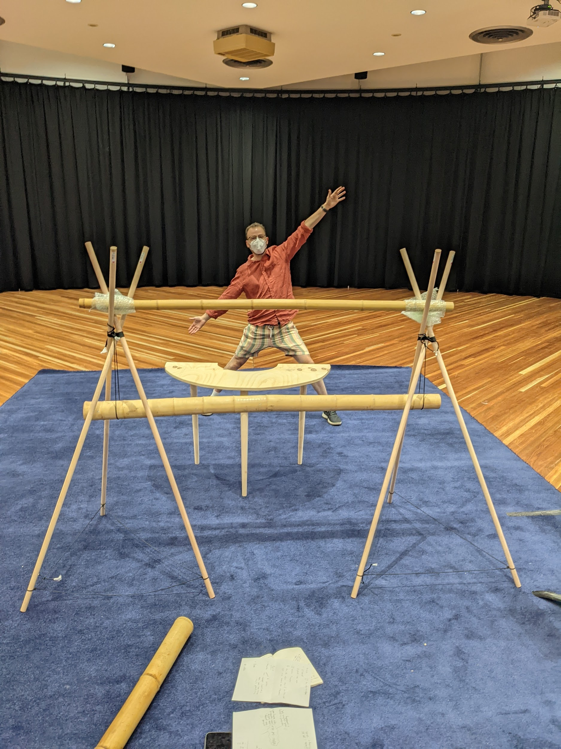

Figure 8. Wooden set up before spray paint finish

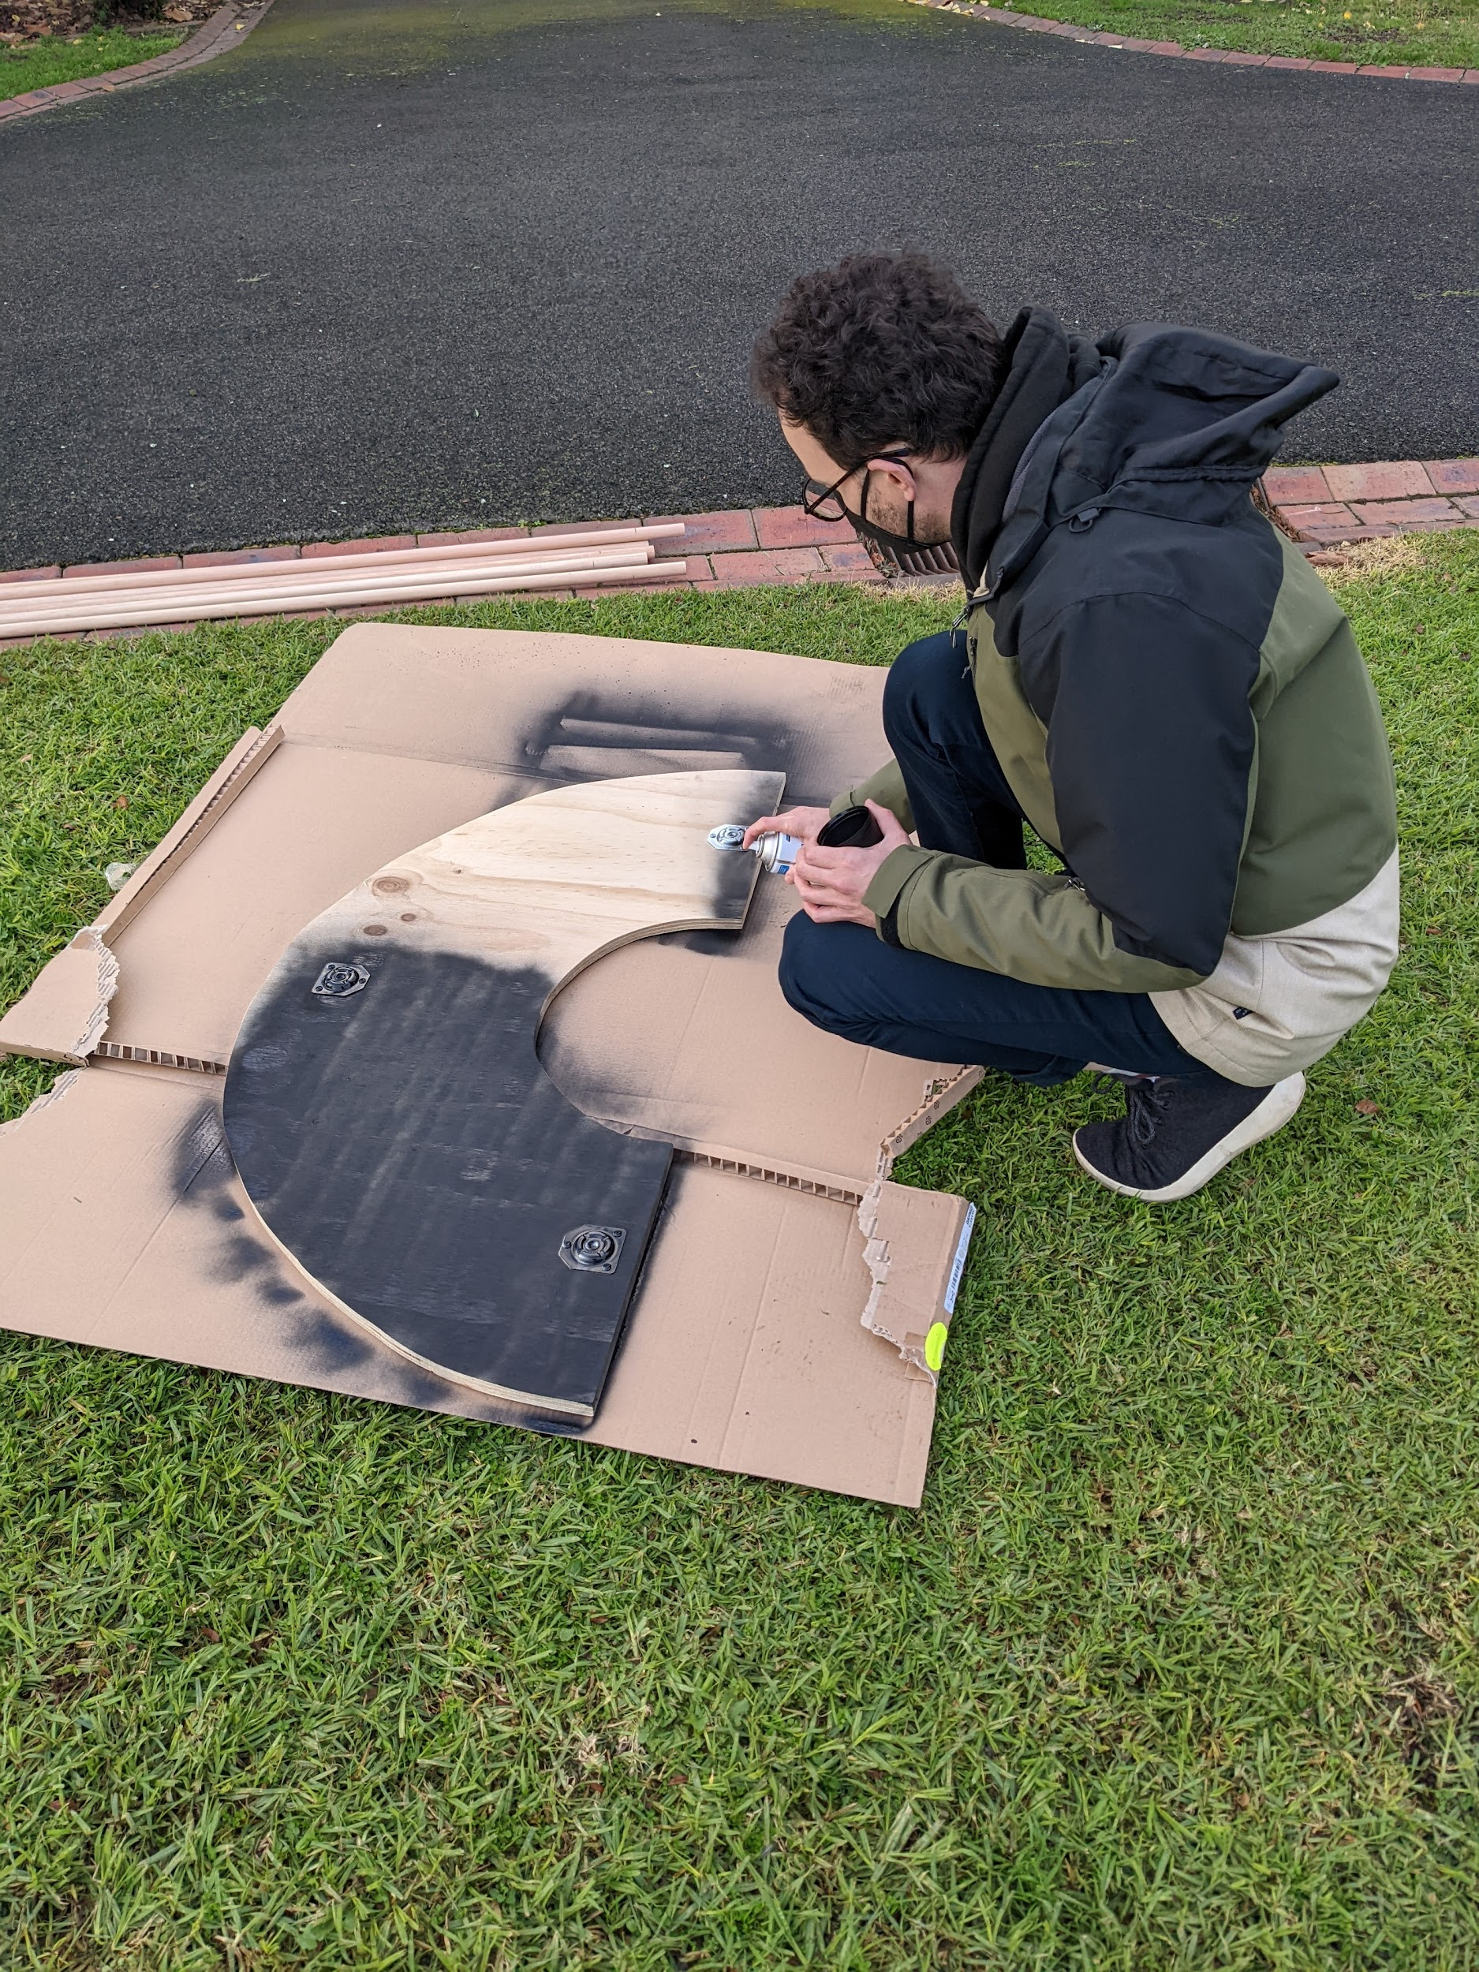

Figure 9. Black spraypainting outside Darebin Arts Centre, 2022

**Installation**

Developing the idea of multiple playing zones spread throughout the room, the artists explored a shared set up in the centre, with two identical / mirrored set ups facing each other at the extreme ends of the room. Each of these setups was to be inhabited at a different point within the composition, and each had a combination of ceramic and bamboo pieces.

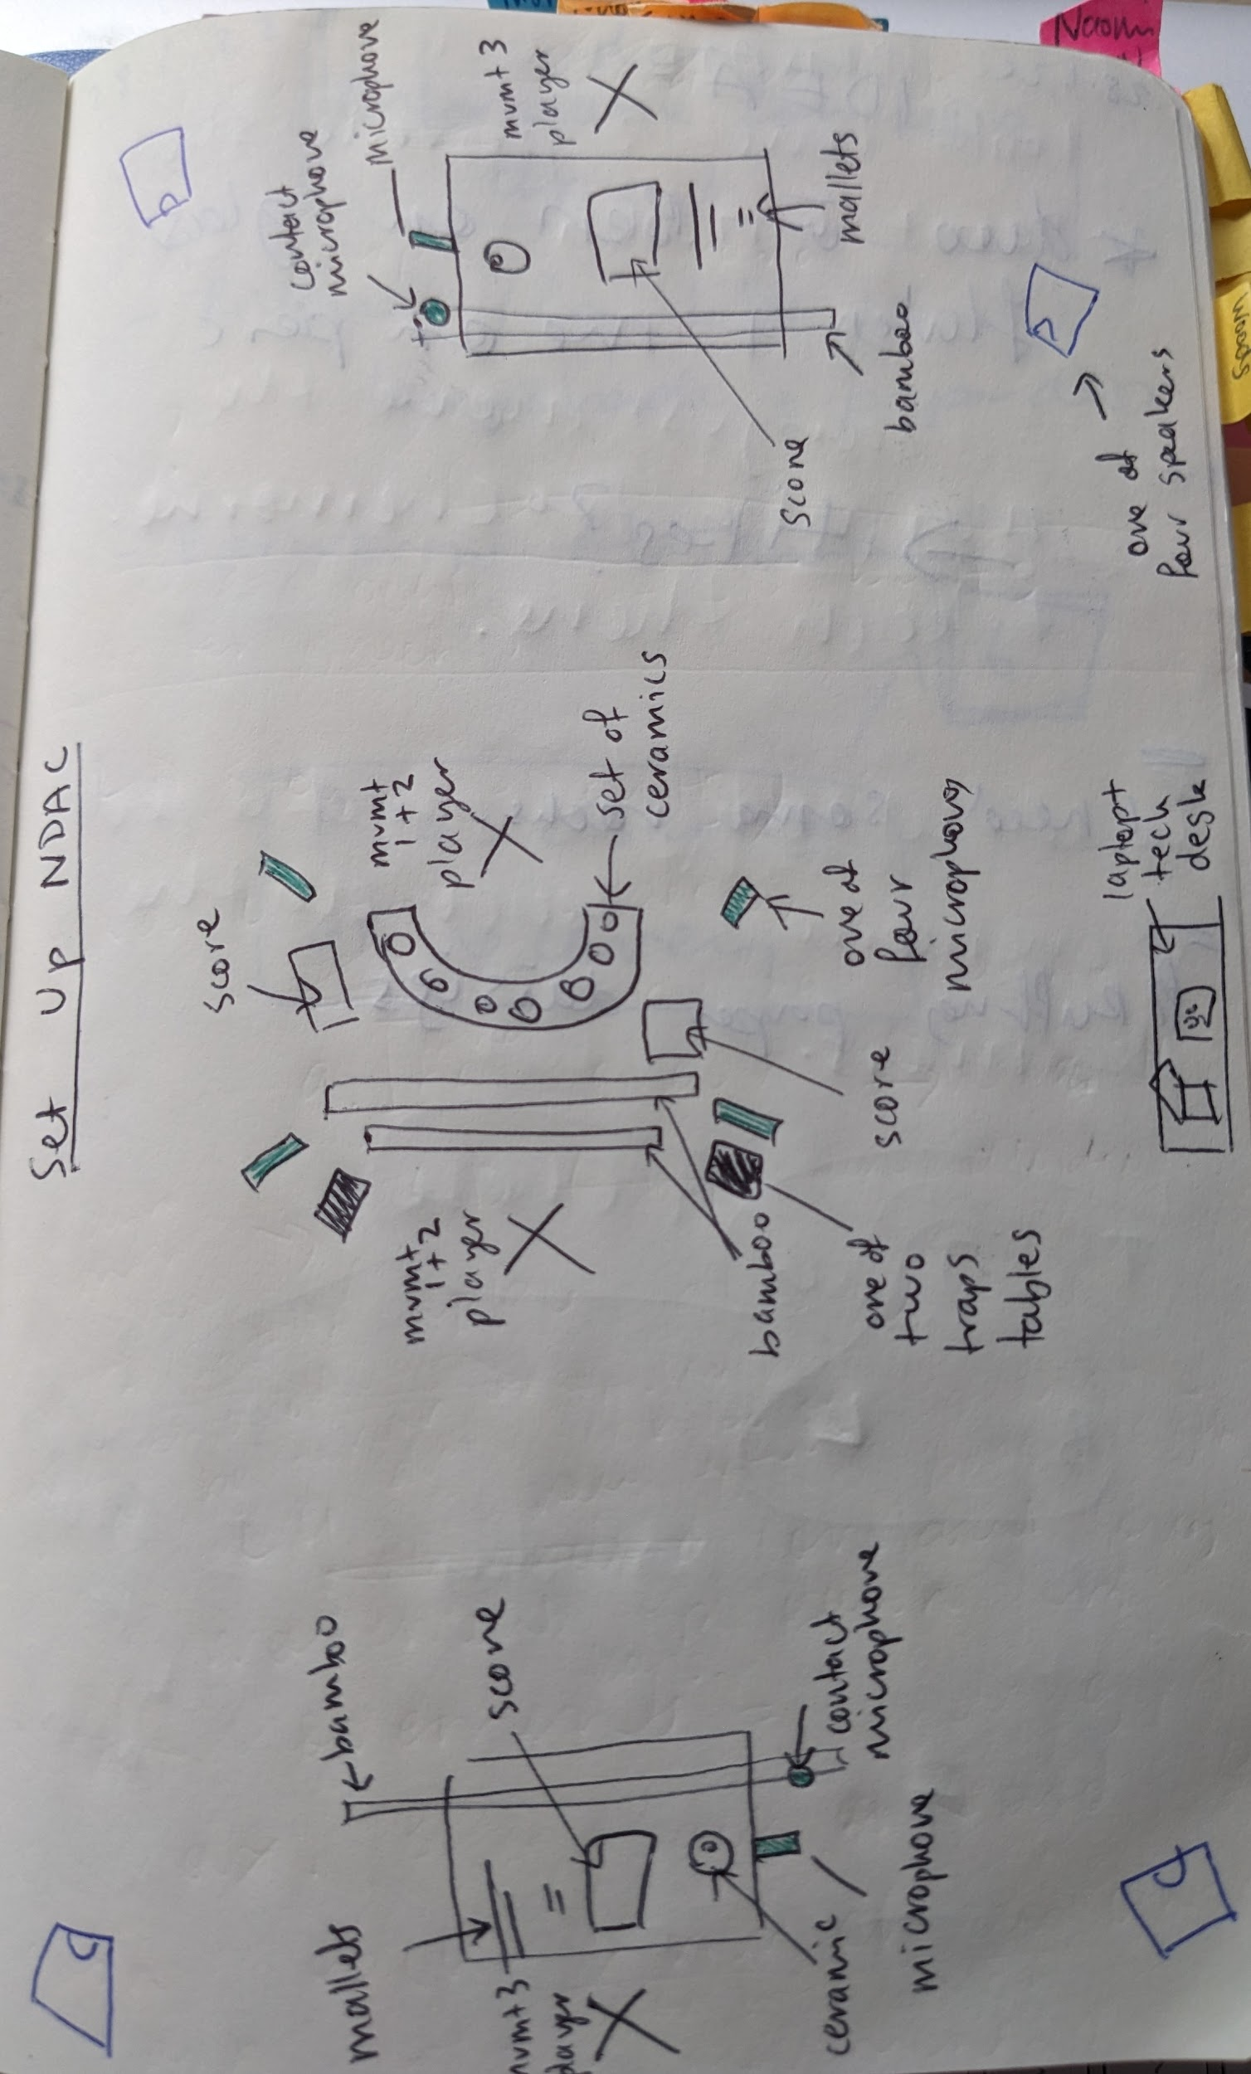

{will need to find a better photo} Figure 10. Performance set up, 2020.

Here, the artists found themselves with a percussion installation involving new ceramic and bamboo instruments. But what did the work sound like? See Part 3 - Composition to find out.

1. Lmao i pretty much plagiarised this sentence from google dictionary
2. Hamish and Niki are deeply grateful for Speak Percussion for providing them the opportunity to develop, and eventually perform this work. Please head to their [website](https://speakpercussion.com/) to check out the amazing work they do.